Trees and Graphs

(For the below tasks, you may want to create a binary tree manually and use the same tree for all of these tasks.)

**NB: All the methods as well as the main method/tester statements must be written in one class. DO NOT write a different class for each method.**

**Compile all your codes and simulation picture in ONE PDF and submit it .**

1. **RECURSIVELY** calculate the height of a tree.
2. **RECURSIVELY** calculate the level of a Node in a tree.
3. Print elements of all the Nodes of a tree using **Pre-order Traversal**.
4. Print elements of all the Nodes of a tree using **In-order Traversal**.
5. Print elements of all the Nodes of a tree using **Post-order Traversal**.
6. An adjacency matrix is given below:

|  | **A** | **B** | **C** | **D** | **E** | **F** | **G** |
| --- | --- | --- | --- | --- | --- | --- | --- |
| **A** | **0** | **1** | **0** | **1** | **1** | **0** | **0** |
| **B** | **0** | **0** | **0** | **0** | **0** | **0** | **1** |
| **C** | **0** | **1** | **0** | **0** | **0** | **0** | **0** |
| **D** | **0** | **0** | **1** | **0** | **0** | **0** | **1** |
| **E** | **0** | **0** | **0** | **0** | **0** | **0** | **0** |
| **F** | **0** | **0** | **0** | **1** | **0** | **0** | **0** |
| **G** | **0** | **0** | **0** | **0** | **1** | **1** | **0** |

1. Draw the equivalent graph.

7. Consider the following tree:

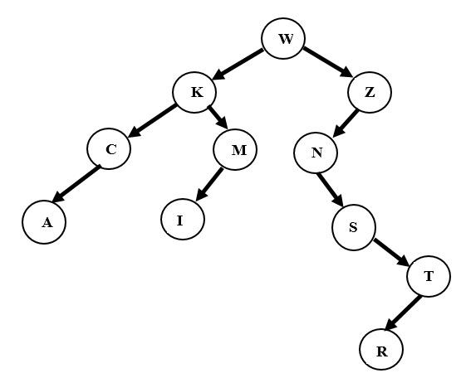

Write down the sequences for: Pre-order, in-order and Post-order Traversal. [2 + 2 +2 Marks]

1. Suppose we need to insert the sequence (3, 51, 6, 65, 17, 12, 1, 22, -3 and 15) into an initially empty binary search tree (of integers). Show the resultant Binary Search Tree.

[4 Marks]

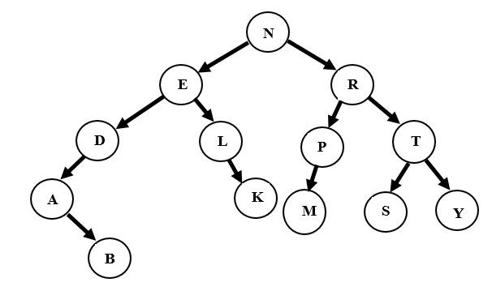

Do the following operations step by step on the above BST: [1 + 1 + 1 Marks]

* 1. Step 1: Remove node E with the help of its successor.
  2. Step 2: Remove node N with the help of its successor.
  3. Step 3: Remove node R with the help of its predecessor.